CMPG 311 Report Assignment 1 (<https://github.com/CMPG311Vaal/mysql-lab-1-KyleHavenga.git>)

Kyle Havenga

30161878

Output

Question 4 number 1

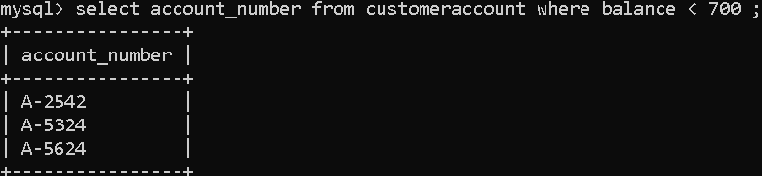

Question 4 number 2

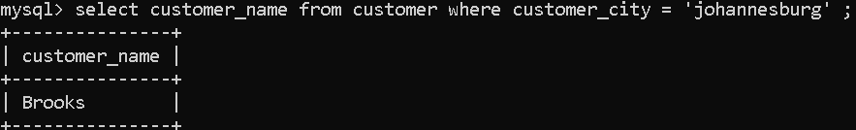

Question 4 number 3

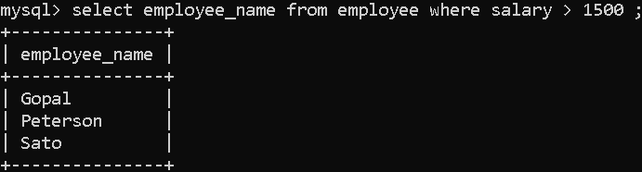

Question 4 number 4

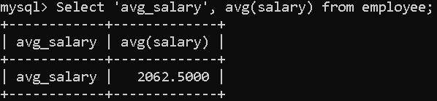

Question 4 number 5

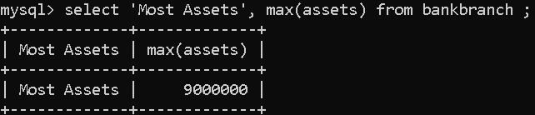

Question 5 number 1

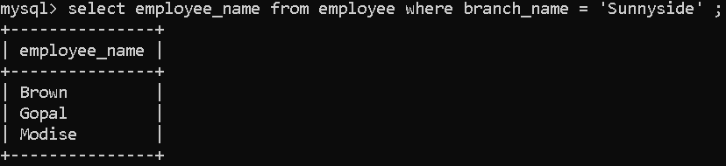

Question 5 number 2

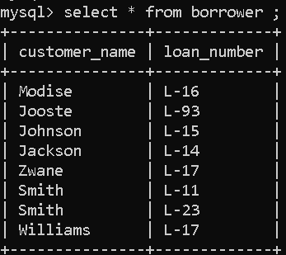

Question 5 number 3



Question 5 number 4

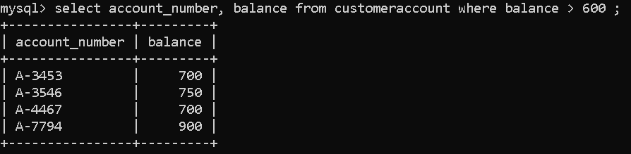

Question 5 number 5

